**Part 1 : ER Diagram**

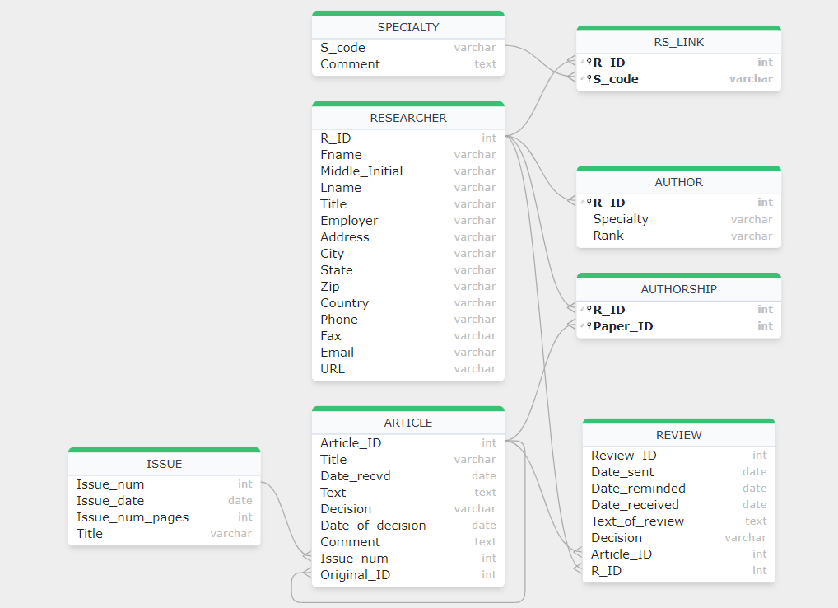

**Part 2: Database Implementation and Data Population**

**(35 points)**

CREATE TABLE ARTICLE (

    Article_ID INT PRIMARY KEY,

    Title VARCHAR(255),

    Date_recvd DATE,

    Text TEXT,

    Decision VARCHAR(100),

    Date_of_decision DATE,

    comment TEXT,

    Issue_num INT,

    Original_ID INT,

    FOREIGN KEY (Issue_num) REFERENCES ISSUE(Issue_num),

    FOREIGN KEY (Original_ID) REFERENCES ARTICLE(Article_ID)

);

CREATE TABLE REVIEW (

    Review_ID INT PRIMARY KEY,

    Date_sent DATE,

    Date_reminded DATE,

    Date_received DATE,

    Text_of_review TEXT,

    Decision VARCHAR(100),

    Article_ID INT,

    R_ID INT,

    FOREIGN KEY (Article_ID) REFERENCES ARTICLE(Article_ID),

    FOREIGN KEY (R_ID) REFERENCES RESEARCHER(R_ID)

);

CREATE TABLE RESEARCHER (

    R_ID INT PRIMARY KEY,

    Fname VARCHAR(100),

    Middle_Initial CHAR(1),

    Lname VARCHAR(100),

    Title VARCHAR(100),

    Employer VARCHAR(255),

    Address VARCHAR(255),

    City VARCHAR(100),

    State VARCHAR(100),

    Zip VARCHAR(10),

    Country VARCHAR(100),

    Phone VARCHAR(15),

    Fax VARCHAR(15),

    Email VARCHAR(100),

    URL VARCHAR(255)

);

CREATE TABLE AUTHOR (

    R_ID INT PRIMARY KEY,

    Specialty VARCHAR(255),

    Rank VARCHAR(100),

    FOREIGN KEY (R_ID) REFERENCES RESEARCHER(R_ID)

);

CREATE TABLE ISSUE (

    Issue_num INT PRIMARY KEY,

    Issue_date DATE,

    Issue_num_pages INT,

    Title VARCHAR(255)

);

CREATE TABLE SPECIALTY (

    S_code INT PRIMARY KEY,

    comment TEXT

);

CREATE TABLE RS_LINK (

    R_ID INT,

    S_code INT,

    PRIMARY KEY (R_ID, S_code),

    FOREIGN KEY (R_ID) REFERENCES RESEARCHER(R_ID),

    FOREIGN KEY (S_code) REFERENCES SPECIALTY(S_code)

);

CREATE TABLE AUTHORSHIP (

    R_ID INT,

    Paper_ID INT,

    PRIMARY KEY (R_ID, Paper_ID),

    FOREIGN KEY (R_ID) REFERENCES RESEARCHER(R_ID),

    FOREIGN KEY (Paper_ID) REFERENCES ARTICLE(Article_ID)

);

**Output :**

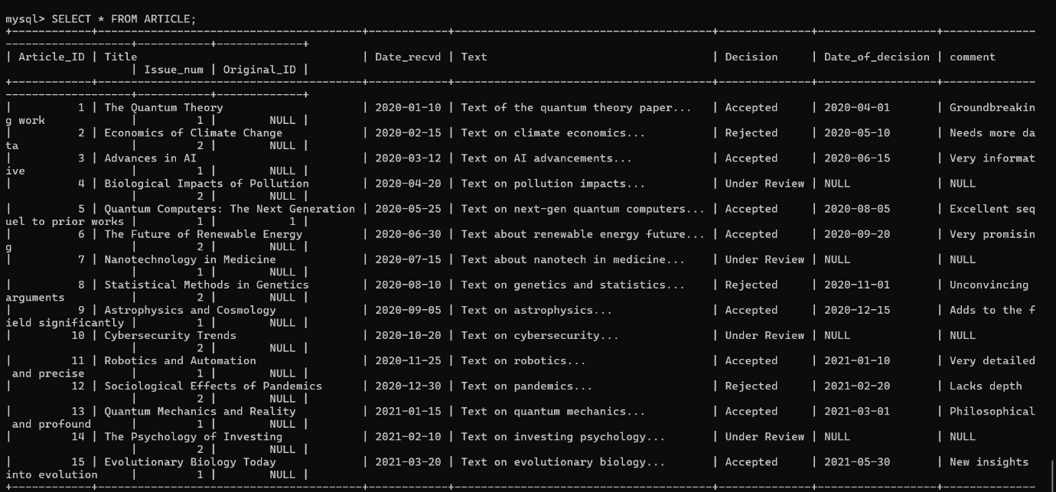

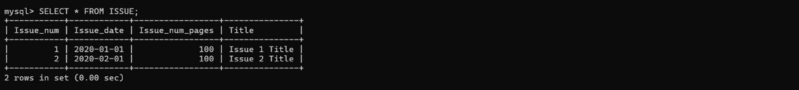

**Part 3: SQL Queries (45 points)**

**1. List the titles of all articles received in 2023.**

SELECT Title FROM ARTICLE WHERE YEAR(Date_recvd) = 2023;

**Output :**

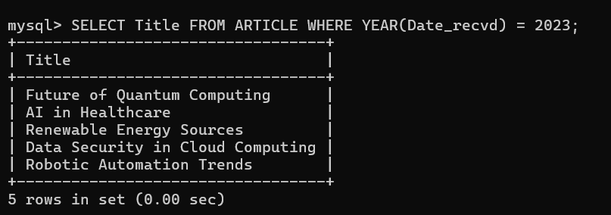

**2.Find the names of all researchers who have written an article about ‘Database Systems’.**

SELECT DISTINCT RESEARCHER.Fname, RESEARCHER.Lname

FROM RESEARCHER

JOIN AUTHORSHIP ON RESEARCHER.R_ID = AUTHORSHIP.R_ID

JOIN ARTICLE ON AUTHORSHIP.Paper_ID = ARTICLE.Article_ID

WHERE ARTICLE.Title LIKE '%Database Systems%';

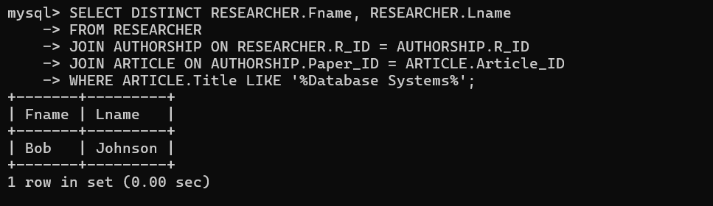

**3.List the articles reviewed by ‘John Doe’.**

SELECT ARTICLE.Title

FROM ARTICLE

JOIN REVIEW ON ARTICLE.Article_ID = REVIEW.Article_ID

JOIN RESEARCHER ON REVIEW.R_ID = RESEARCHER.R_ID

WHERE RESEARCHER.Fname = 'John' AND RESEARCHER.Lname = 'Doe';

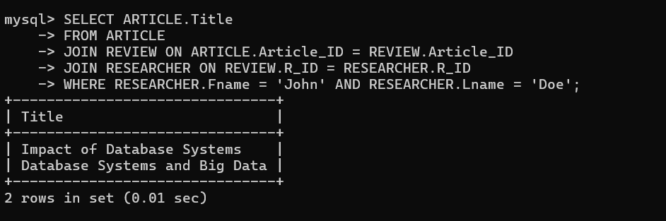

**4.Find the number of articles received by each issue.**

SELECT Issue_num, COUNT(*) AS Articles_Count

FROM ARTICLE

GROUP BY Issue_num;

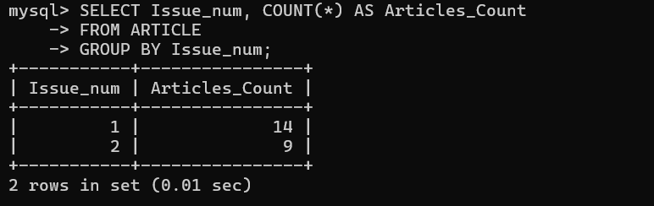

**5.List the authors who have written more than 5 articles.**

SELECT RESEARCHER.Fname, RESEARCHER.Lname

FROM RESEARCHER

JOIN AUTHORSHIP ON RESEARCHER.R_ID = AUTHORSHIP.R_ID

GROUP BY RESEARCHER.R_ID

HAVING COUNT(AUTHORSHIP.Paper_ID) > 5;

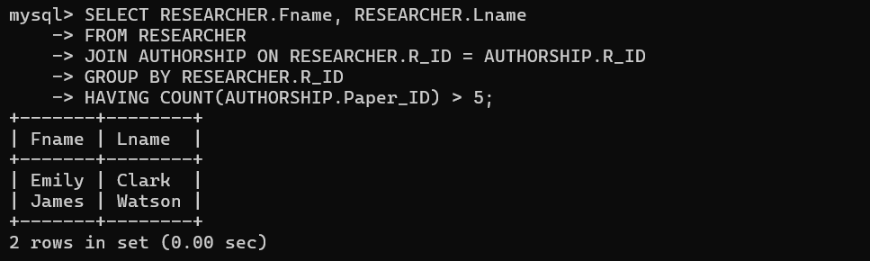

**6.Find the most common specialty among authors.**

SELECT Specialty, COUNT(*) AS Count

FROM AUTHOR

GROUP BY Specialty

ORDER BY Count DESC

LIMIT 1;

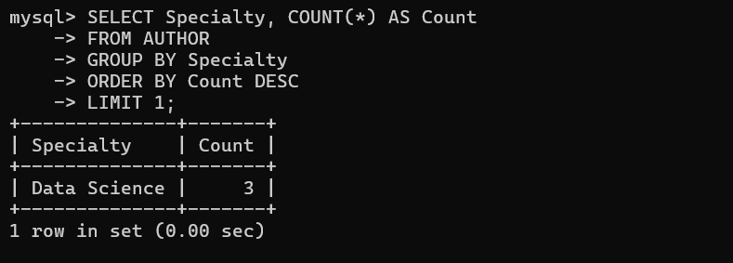

**7.List the articles that have not yet been reviewed.**

SELECT Title

FROM ARTICLE

WHERE Article_ID NOT IN (SELECT Article_ID FROM REVIEW);

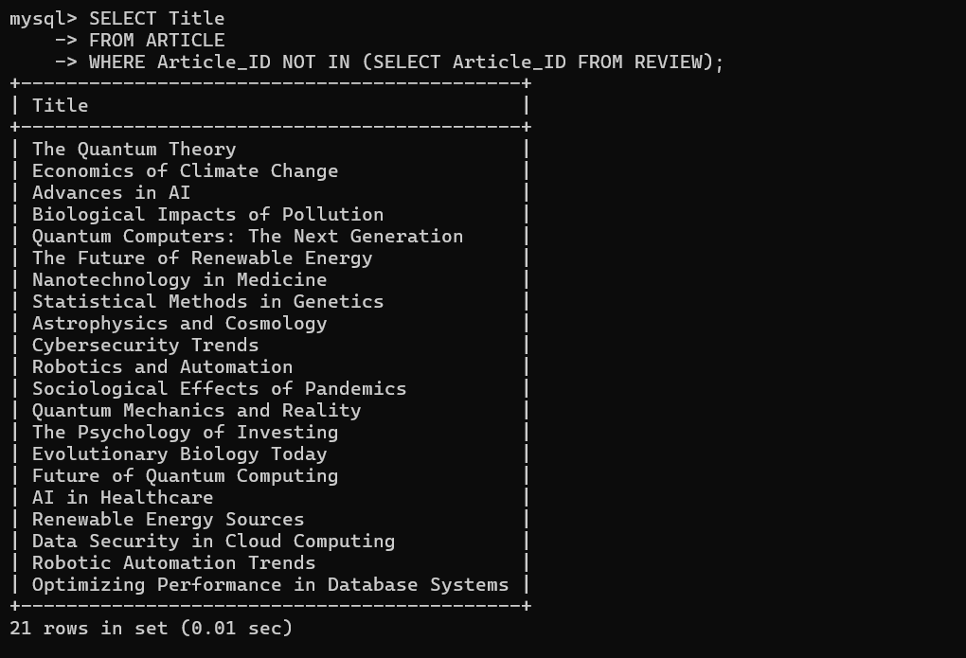

**8. Find the average number of pages per issue.**

SELECT AVG(Issue_num_pages) AS Average_Pages

FROM ISSUE;

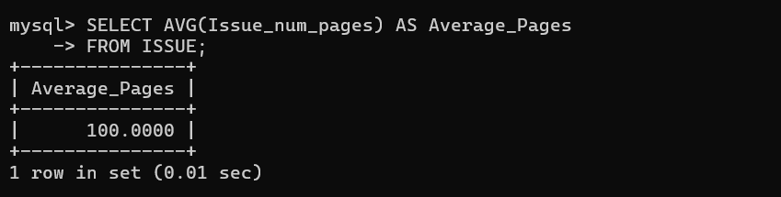

**9.List the researchers who have both written and reviewed articles.**

SELECT DISTINCT RESEARCHER.Fname, RESEARCHER.Lname

FROM RESEARCHER

JOIN AUTHORSHIP ON RESEARCHER.R_ID = AUTHORSHIP.R_ID

JOIN REVIEW ON RESEARCHER.R_ID = REVIEW.R_ID;

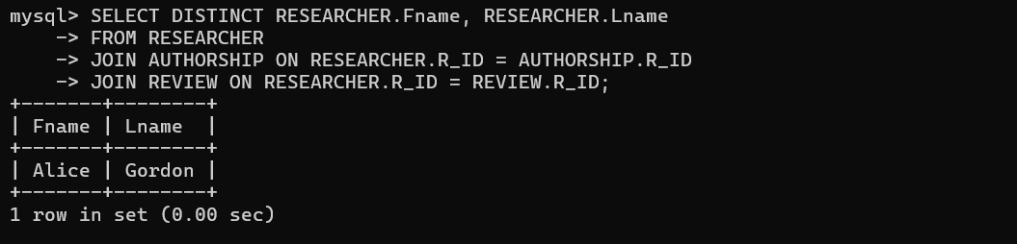

**10. Find the titles of articles that have been both accepted and rejected.**

SELECT Title

FROM ARTICLE

WHERE Article_ID IN

    (SELECT Article_ID FROM ARTICLE WHERE Decision = 'Accepted')

AND Article_ID IN

    (SELECT Article_ID FROM ARTICLE WHERE Decision = 'Rejected');

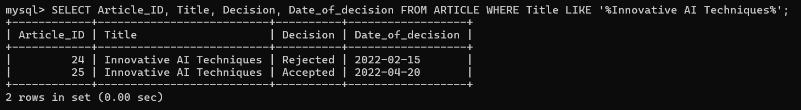

**11. List the researchers who have a specialty in ‘Database Systems’.**

SELECT RESEARCHER.Fname, RESEARCHER.Lname

FROM RESEARCHER

JOIN AUTHOR ON RESEARCHER.R_ID = AUTHOR.R_ID

WHERE AUTHOR.Specialty = 'Database Systems';

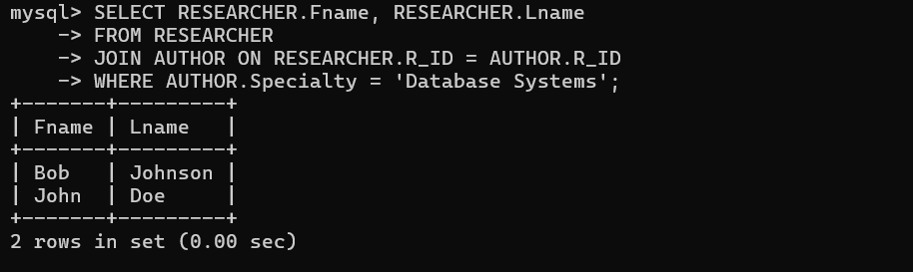

**12. Find the issues that have more than 50 pages.**

SELECT Issue_num, Title

FROM ISSUE

WHERE Issue_num_pages > 50;

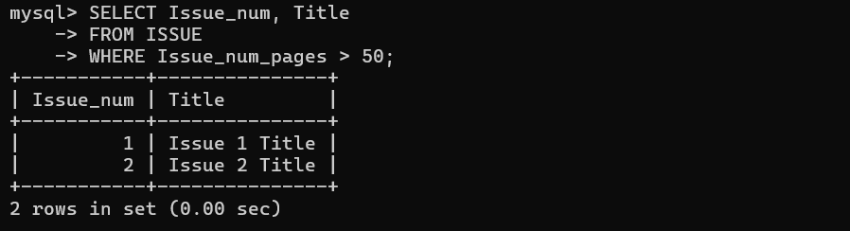

**13. List the articles that have been reviewed more than twice**

SELECT ARTICLE.Title

FROM ARTICLE

JOIN REVIEW ON ARTICLE.Article_ID = REVIEW.Article_ID

GROUP BY ARTICLE.Article_ID

HAVING COUNT(REVIEW.Review_ID) > 2;

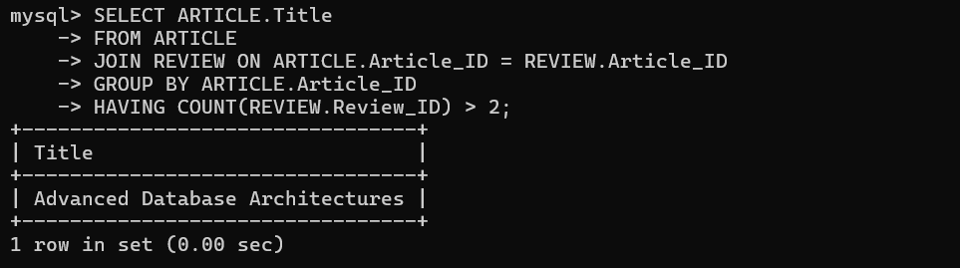

**14. Find the researcher with the most articles.**

SELECT RESEARCHER.Fname, RESEARCHER.Lname

FROM RESEARCHER

JOIN AUTHORSHIP ON RESEARCHER.R_ID = AUTHORSHIP.R_ID

GROUP BY RESEARCHER.R_ID

ORDER BY COUNT(AUTHORSHIP.Paper_ID) DESC

LIMIT 1;

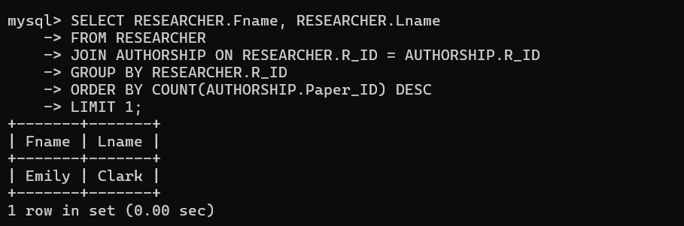

**15. List the specialties that have more than 10 researchers.**

SELECT Specialty, COUNT(*) AS Researcher_Count

FROM AUTHOR

GROUP BY Specialty

HAVING COUNT(*) > 10;

